
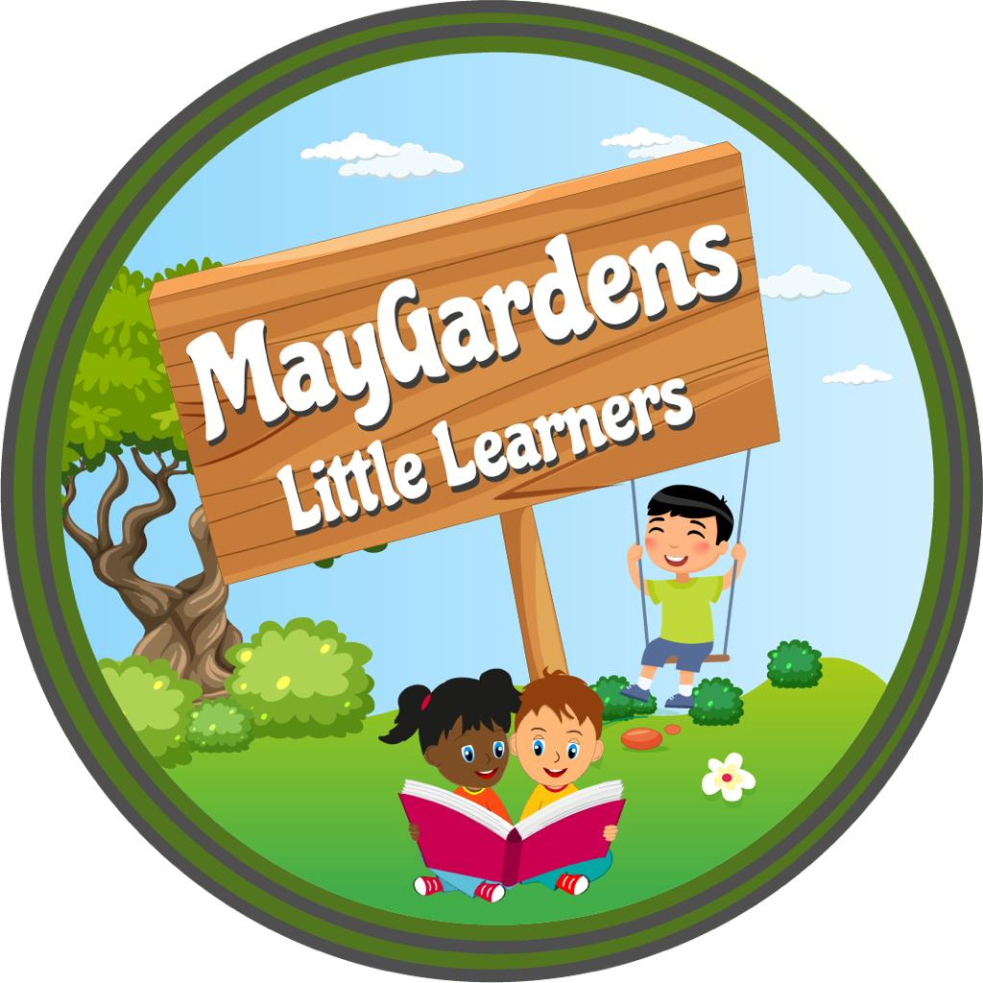

Family Booklets
If you haven’t done so already,
Please send family pictures
to our email address and we
will make a booklet for your
little one to be kept in the
nursery to look through
and share with their friends.
Stay and Play
Every Day 10-11 or 2-3
Must be booked in advance
by emailing the nursery one
week before.
Traditional items
We are always looking into
making our nursery more
inclusive and one way of
doing this is to have
traditional items in our
nursery to reflect where our
children coming from.
If you have any clothing
or items to donate we will
love to have them.
Examples of these may be :
Books, kitchen items,
Fabrics, old pictures and decorations.


Start of Summer Term: Monday 13 April 2026
Half term: Monday 25 May to Friday 29 May 2026
Spring Bank holiday: Monday 25 May 2026
End of Summer Term: Thursday 23 July 2026
Summer holiday bank holiday: Monday 31 August
Start of Autumn Term: Wednesday 2 September

April 2026
Summer term dates  Parents Meeting: 12th of April until 1st of May  Parents Evening chat (Topic School Readiness)- to be confirmed  Graduation Day Saturday, 11th of July from 12-1pm  Fun Day Saturday, 11th of July from 1pm to 5 pm  Bank Holidays (nursery closed for all children)  4 May 2026 (May Day Bank Holiday)  25 May 2026 (Spring bank holiday)  31 August 2026 (August bank holiday)  Inset Day(nursery day closed for all) Friday, 7th of August | “Family, Community, Children’s Rights Based Practice  Welcome to our Summer Term newsletter. We are looking forward to a lovely term ahead, filled with fun activities, learning, and exciting experiences for the children.  Theatre show  A Big Thank You for Joining Our Theatre Show!  We would like to extend a heartfelt thank you to all the parents who brought their children to our recent theatre event! It was wonderful to see the children so excited and engaged throughout the performances.  The children enjoyed Old McDonald’s Farm and The Three Little Pigs, brought to life with puppets, rhymes, and playful alliteration. These stories weren’t just fun—they offered a fantastic opportunity for learning! Through the show, children practiced:  Communication and Language – exploring new vocabulary and expressing themselves.  Listening and Attention – following the story and engaging with the action.  Phonics – noticing sounds and letter patterns in words.  It was amazing to see children joining in with the rhymes, reacting to the puppets, and enjoying the stories while developing key early literacy and listening skills—all in one magical experience.  Family Booklets  As you may already know, we are creating  special family booklets for the children. If  you haven’t yet done so, please send in  photos of close family members, as these  help children feel more secure, support their  communication, and encourage  conversations about their home life.  Thank you for your support.  Stay and Play  Our Stay and Play sessions continue as  usual, 9–10 am or 1–2 pm every day.  Sessions are bookable one week in advance.  We look forward to welcoming you and  your child!  Think Equal Updates  So far, after 8 weeks of think equal lessons!  The children are showing real enjoyment in the  Activities! They are showing signs of emotional  Progress, they have become more considerate  Of others and have a better understanding of  their own emotions as well as others!  Weekly Trips Restarting  We’re excited to announce that our weekly outings are restarting!  Children will be going out in small groups of up to 6, allowing  For a safe, engaging, and meaningful experience the  local community around Northolt.  🌍 Where we’ll be going:  - Local playgrounds  - Dentist visits (to support oral health awareness)  - Train station (exploring transport and the world around us)  - Libraries (encouraging early reading and a love for books)  - Local shops (real-life learning and communication skills)  - Parks and nature walks  - Community spaces and green areas  🎯 What children gain:  - Confidence in new environments  - Social and communication skills  - Understanding of the local community  - Real-world learning experiences  - Physical activity and exploration  Labelling your child’s items  We kindly ask all parents to clearly label their child’s  belongings, including coats, bags, bottles, and spare clothing.  Labelling helps prevent items from getting lost or mixed  up, especially as many children have similar items. It also makes  it easier for staff to return belongings quickly and supports children  in recognising their own things.  Thank you for your cooperation and support.

